**JA5 Home School Learning**

Hello Group

Hello Song

<https://youtu.be/CuI_p7a9VGs>

Day of the Week Song

<https://www.youtube.com/watch?v=LIQsyHoLudQ>

Weather song

<https://youtu.be/Jn7uAsLWXpk>

Snowman Freeze

<https://www.youtube.com/watch?v=C0tVmABwMPs>

Snow

<https://www.giftofcuriosity.com/puffy-paint-snowman/>

Phonics S sound

<https://www.youtube.com/watch?v=ECjT3XFz04U>

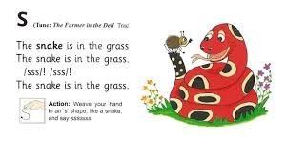

Make a collection of things at home beginning with s

My Well-Being

Yoga for kids - The Butterfly Pose



<https://www.youtube.com/watch?v=oYI0TPJOuGk>

Also some lovely mindfulness clips to encourage relaxation

**Story – The Snowy Day**

<https://youtu.be/FmZCQfeWjeQ>



Play

