**JA5 Home School Learning**

Hello Group

Hello Song

<https://youtu.be/CuI_p7a9VGs>

Day of the Week Song

<https://www.youtube.com/watch?v=LIQsyHoLudQ>

Weather song

<https://youtu.be/Jn7uAsLWXpk>

Penguin Song https://www.youtube.com/watch?v=-scENG_uisc

Hot and Cold

PHONICS - Introducing ‘a’ - Jolly Phonics

<https://www.youtube.com/watch?v=ZwxnPcvseVo>

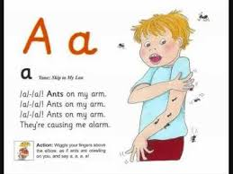

Story Massage – A Winter Walk

<https://youtu.be/onSKmPcKwS4>

Circle time – dressing for cold weather – gloves, hat, scarf, mittens, coat, boots

Choosing the right items (verbal instruction or visual symbol) and naming them

Using Makaton signs for hot and cold

Colour of the Month – White

Sorting groups of white things from a selection of coloured objects

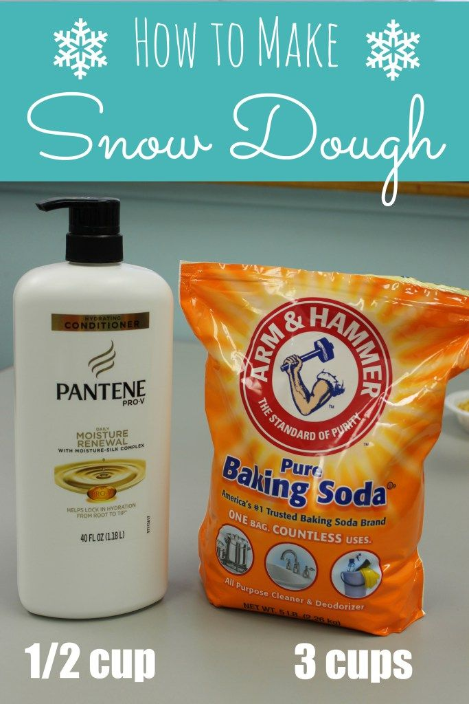

Sensory Play

Play-Based Learning

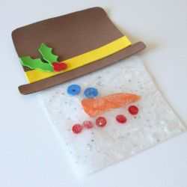

Make hot chocolate using chocolate buttons and warm milk

