STAYING ACTIVE HAVING FUN

Movement is a very important for all our children to stay fit and healthy and further develop gross motor skills.
Try and build in some form of activity each day. This can be done in several short bursts or in one longer period. Let your child lead you.
Involve the whole family
If the weather is good go outside if you have space.
Blow bubbles in different directions – get your child to reach up/down/to the side to catch the bubble. Try to stamp on the bubble. This is a good activity for balance and cordination
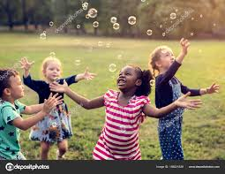

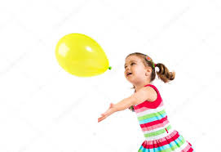
Practise throwing and catching – use baloons, different size balls or any suitable objects

Make up obstacle courses – use chairs, boxes, small steps, any everyday items, cushions, pillows
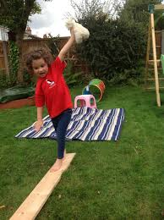
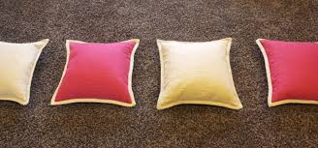
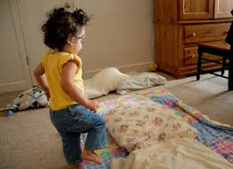

Practice crawling over and under different surfaces. 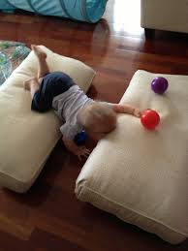
Try some balance activity. Get your child to copy your silly poses.

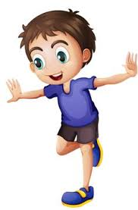
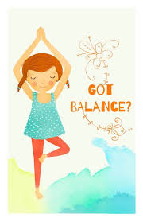

Put on some music and dance like no one is watching
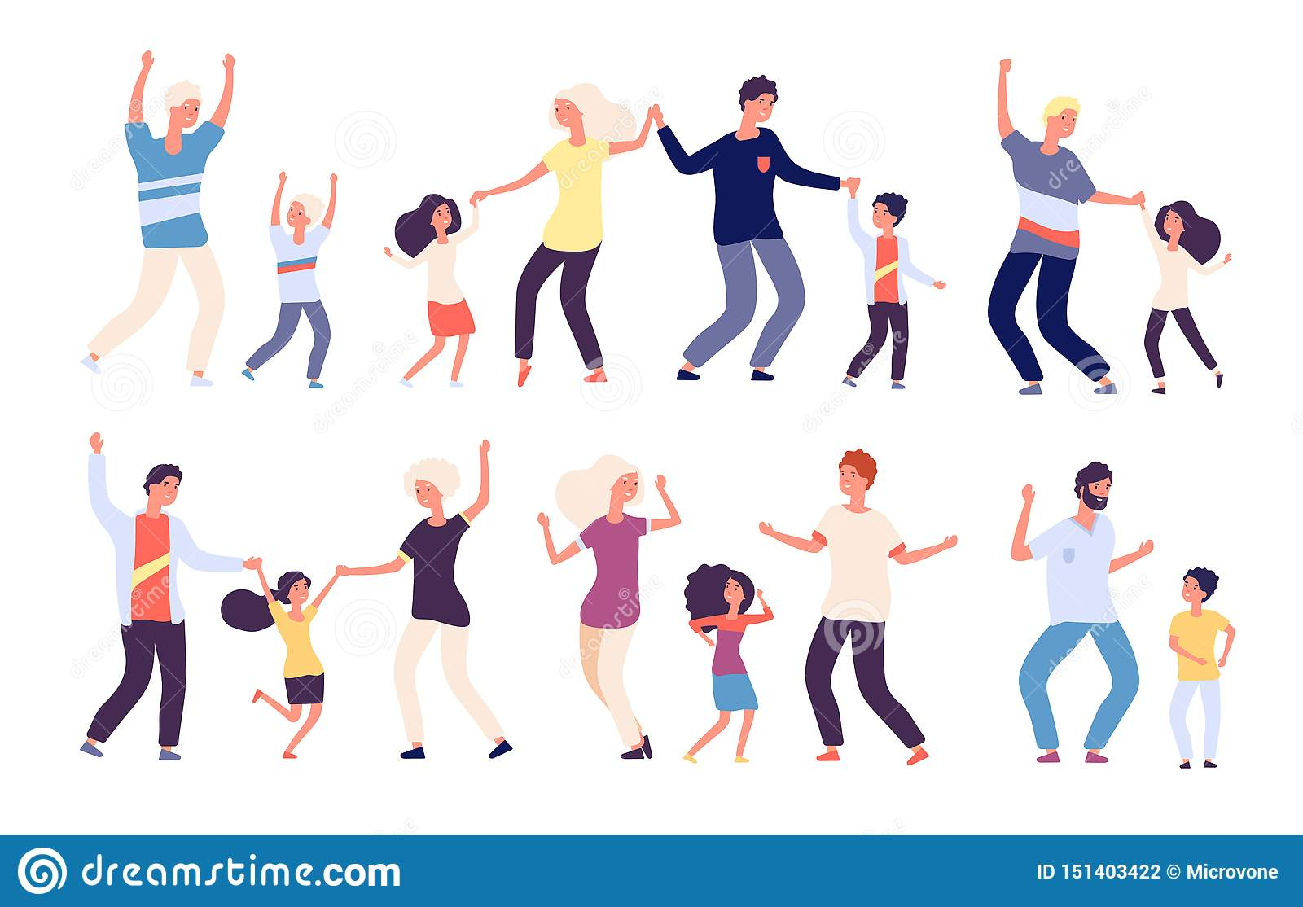
You may like to record your activity on the chart I have included.

