Hi Everyone,
So the Corona virus has been the cause of a lot places and activities shutting down at present but one thing that has not stopped is housework!!
So here are a few reasons why you should be getting your little people involved and the therapeutic benefits for your kiddos!

Ten Benefits Of Chores

1. Learn an important life skill
Whether we like it or not, household chores are a necessary part of everyday life, ensuring that our homes continue to run efficiently, and that our living environments remain organized and clean, thereby promoting good overall health and safety.
When cognitive abilities permit, it is important for individuals with challenges to gain some type appreciation of this.

2. Beneficial to siblings
It is helpful for siblings of kids who have disabilities to see that everyone in the family participates in keeping the family home running, each with responsibilities that are appropriate for his or her unique skill sets and abilities.

3. Purpose
Having responsibilities like chores provides one with a sense of both purpose and accomplishment.

4. Preparation for Employment
Learning how to carry out household chores is an important precursor to employment. Chores can serve as an opportunity to explore what your child excels at and could possibly pursue as a job down the road.

5. Make your life easier

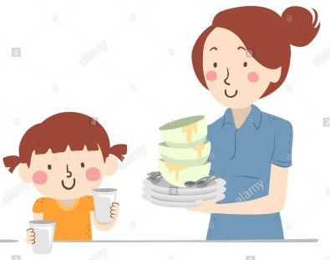
Your kids can actually be of help to you! At first, teaching these chores may require more of your time and energy, but in many cases your child will be able to eventually do his or her chores completely independently, ultimately relieving you of certain responsibilities.

6. Chores may make your child more accountable
If your child realizes the consequences of making a mess, he or she may think twice, knowing that being more tidy in the present will help make chores easier.

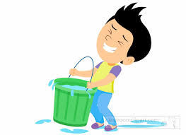
7. Develop fine and gross motor skills and planning abilities
Tasks like opening a clothes pin, filling and manipulating a watering can and many more actions are like a workout for the body and brain and provide practical ways to flex those muscles!

8. Teach empathy
Helping others out and making their lives easier is a great way to teach empathy. After your daughter/son completes a chore, you can praise and thank her/him, stating, “Wow… great job! Because you helped out, now Mummy has one less job to do. I really appreciate that!”

9. Strengthen bonds with pets
There is a growing body of research about how animals can help individuals with special needs. When your child feeds and cares for his/her pet, it strengthens their bond and makes your pet more likely to gravitate toward your child.

10. Gain an appreciation and understanding of currency
What better way to teach your child the value of money than by having him/her earn it.

Therapeutic Benefits:
Here is a short breakdown of many common chores and the therapeutic benefits they provide.
Cleaning up toys: Just like playing with and manipulating toys is beneficial to hand and grasp development, so is cleaning them up. Many times, taking apart toys such as blocks, puzzles and games requires additional fine motor strength and dexterity. In addition, having designated spots for items assists with sorting and direction following.
Dusting: Whether you use a dusting wand or cleaner and cloth, dusting promotes crossing midline while increasing stability of the shoulder and elbow. In addition, dusting can also be a great visual scanning activity by helping children learn they have to scan an entire table or shelf to make sure the dust is gone. Remember that it is ideal to make sure you are practicing this using both hands.

Cleaning widows: Just like dusting, this is another way to address midline crossing and shoulder stability. But by throwing in the vertical component of standing, the challenge and benefit increase.

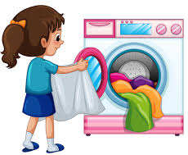
Laundry: By simply cleaning those dirty clothes off the floor, direction following and sorting are addressed. Pushing or carrying the laundry baskets to and from the laundry room can help achieve proprioceptive input as well as bilateral coordination, shoulder stability and grip strength. For higher-level children, folding helps improve shoulder, wrist and hand development as well as dexterity and precision. For this skill to be the most successful, starting with towels and progressing to pants and shirts is best. And who doesn’t want help with matching those socks, which improves visual and sorting/matching skills? This is a great task for your littler ones. Sequencing of a multiple-step task can be addressed by having your child actually use the washer and dryer.

Vacuuming: This is a great bilateral coordination task that provides proprioceptive input while improving shoulder stability. In addition, hand strength is addressed, as children have to maintain their grasp for a prolonged period. Again, visual scanning is required to ensure a full room is cleaned.
Emptying the dishwasher: Even for children who cannot reach the cabinets, emptying the dishes and sorting them on the counter provides practice in grasping items of different sizes and weights. Bilateral skills are required to perform this task, especially if children have to dry off excess water. Like so many of our chores, this is another one that helps improve shoulder, elbow and wrist stability.
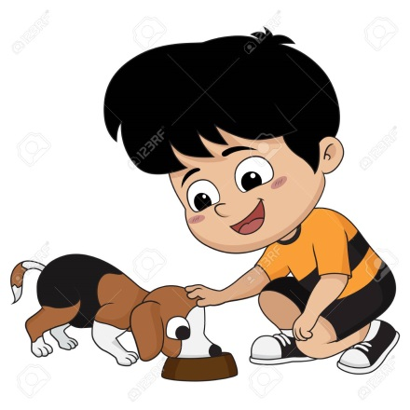
Taking out the Rubbish: Whether your child has to push/pull the bin to the pavement or carry out the bag to the bin, this is a great proprioceptive, strengthening and bilateral coordination task.
Feeding pets: Not only is this a great task to teach responsibility for others, but feeding pets also addresses sequencing and multiple step-following skills. In addition, based on how it is set up, carrying food and water bowls improves shoulder stability and balance, a functional skill that can be similar to carrying a lunch tray at school.
Yard work: The list of benefits is long for these tasks. From raking to lawn mowing to weeding, children can work on bilateral coordination, core stability and strengthening, as well as grasp development and strength.
So, now the challenge is how to put a “fun” twist on something that is so often dreaded at home…the CHORE list! Helping establish a routine/schedule or developing a game approach can be helpful based on the child’s personality. From to making a game spinner to choose the chore to be done, there are plenty of ways to help make this a win-win experience!
Some ideas to help make housework fun!!
- Hide treats, stickers, or pennies in, on, or under knickknacks, then ask your child to dust. He/She gets to enjoy the rewards only when everything is dusted.

- Post individual lists of chores kids can do (one for each child in your family). Whenever your child accomplishes a task, have him/her mark it with a sticker. Whoever has the most stickers at the end of the week gets the Helper of the Week award.

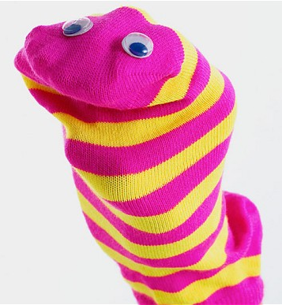
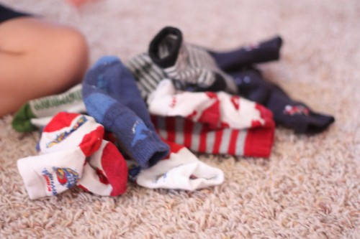
- Play "Go Fish" with a basket of clean socks. Divide the socks among the players, leaving a pile to draw from. Each player, in turn, holds up a sock and asks another player if he has the mate. If not, the asking player must take a sock from the top of the draw pile. When finished, the player with the most pairs wins.

- Turn any socks that stay single into child-friendly dust mitts. Insert child's hand into clean but dampened sock and use it to remove dust from houseplants and furniture.

- Have a scavenger hunt. Make a list of everyday items (newspapers, magazine, shoes, etc.). Set a timer for 5 minutes, then have kids collect stray items throughout the house. The winner is the child who picks up the most (and returns them to their rightful spots).

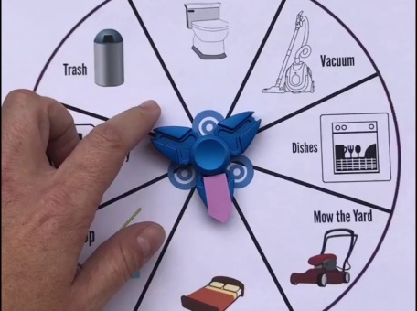
- Trying to “beat the song” when cleaning up toys.

- Making a game spinner to choose the chore to be done.

- Beat the adult – set a chore for each of you to do and see who finishes first. Play fair and make sure they are equal levels of difficulty!

Have fun with your busy bees!

